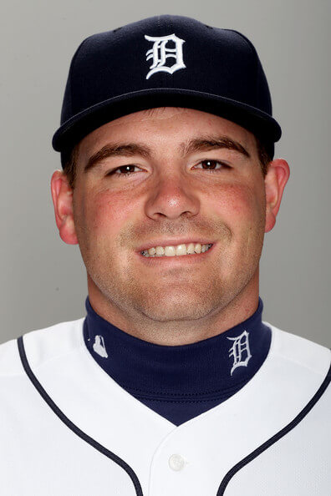
Kenny Faulk
770-362-0860
Kfaulk19@yahoo.com
Objective:
To use my extensive knowledge of pitching to help players understand all aspects of pitching. I am very passionate about teaching proper mechanics and instilling a strong mindset in pitchers! My goal is to contribute to the development of every client in each and every session.
Education:
Kennesaw State University- Degree in History with a minor Education 2006-2015. (Completed degree after retiring from Minor League Baseball)
Woodstock Highschool graduate 2002-2005 (3.8 GPA)
Experience:
2009-2015- Detroit Tigers – Left-Handed Pitcher – Played 6.5 seasons at all levels ranging from A-AAA
2009-2011- North Cobb High School- Varsity coach- Oversaw the fall program that had a record of 28-5
2012-2013 – East Cobb Patriots – Pitching Coach – (15-18u) Fall coach during MILB offseason
2013-2014 – Nelson Baseball School – Assistant Coach – Fall pitching coach for NBS 17u. Also, assisted with the Youth Nelson Baseball School ages (10-14u) helped with practices, camps and clinics
2015- East Cobb Baseball – Assistant coach/Pitching coach for the 17u Astros in Summer
2015-2017 – Southern Union State Community College – Pitching coach and recruiting coordinator
2017- Current- East Cobb Baseball – Director of Operations – Oversee day to day operations for ECB Pitching Instructor – private lessons in the ECB Academy – Certified Instructor
Achievements:
- 2005 All Region/ All County Selection (Woodstock HS)
- 2006- All Tournament Juco selection (Andrew College)
- 2007- Top 100 LHP in country among junior colleges
- 2009- Atlantic Sun All Conference Selection
- 2009- 16th round pick Detroit Tigers
- 2009- New York Penn League All Star
- 2010- Finished second in the league with number of appearances, 2x West Michigan White Caps Player of the Week.
- 2011- Finished 29/32 in saves with 81 Innings Pitched with just 27 walks to 109 Strikeouts with a 1.89 ERA (June 2010-2011)
- 2011- Florida State League All Star Selection
- 2012- Eastern League All Star Selection, Lead Double A relief pitchers with 10.6 Strikeouts Per 9 innings.
- 2013- Detroit Tiger major league camp invite, Arizona Fall League Invite. Had a stretch of 31 Innings pitched while only allowing 4 Earned Runs and 32 strikeouts in AAA
- 2015- Retired from the Detroit Tigers. Ended career ranked as high as the number 12 MLB Prospect for the Detroit Tigers. Final professional baseball stats 3.55 ERA in 317 IP with 385 Strikeouts and 47 professional saves.
- 2015-2017- Southern Union Community College: Every player ended up signing to a 4-year program. Led Southern Union to have the second lowest ERA out of 18 teams in 2015. Coached first collegiate MLB Cooper Criswell, who signed to UNC and made it to the MLB with the Angels.

