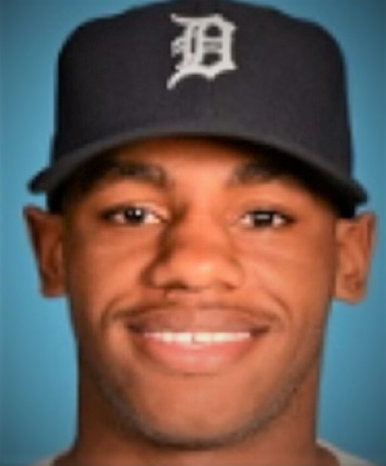
Rashad Brown
470-808-0066
Objective:
To instruct players and elevate their skills to become proficient hitters and defenders. My objective is to implement personalized training programs that help develop players swing mechanics, hitting approach and athleticism in the box! Through my passion and knowledge for the game, I strive to inspire a growth mindset and strong work ethic for all of my players.
Background:
I am a native of Atlanta, Georgia. I attended Douglas County high school from 2010 & 2011 along with being at Westlake high school in 2009 & 2012. While in high school I was a four-year letterman, 3-time All-Region player and a Rawlings Preseason All-American honorable mention recipient. Following high school I was drafted by the Detroit Tigers in 2012.

Experience:

2012-2016- Detroit Tigers- outfielder – career .269 hitter/ 50 SB in 275 games

2017- Washington Wild Things – All-Star selection and Fran Riordan Award (Citizenship Award)

2018- Current – ECB Certified hitting instructor/coach

